Halo PTEC Ring Field Spine
White Paper Proof of Concept for a Circular PTEC Field Manifold
Document Type | High-level shielding and field-manifold proof-of-concept white paper
Concept Thesis | Wrap the spine into a circular backbone and distribute PTEC nodes around it so the ring behaves as a continuous field manifold for EM generation and shield-lattice support.
Primary Use | EM field generation, shield support, sector reinforcement, and field balancing
Status | Concept architecture draft
Abstract
Halo PTEC Ring Field Spine is a field-architecture concept in which a spine system is wrapped into a circular backbone and populated with distributed PTEC nodes. Rather than treating shielding as the output of one central emitter, the ring acts as a continuous field manifold: energy circulates around the loop, PTEC nodes feed oscillation and induction into the structure, and hull-coupled lattice surfaces draw from the ring to form an electromagnetic or shielding envelope. The result is not a one-piece magic shield, but a more coherent generation, balancing, and distribution architecture for field support across a protected volume.
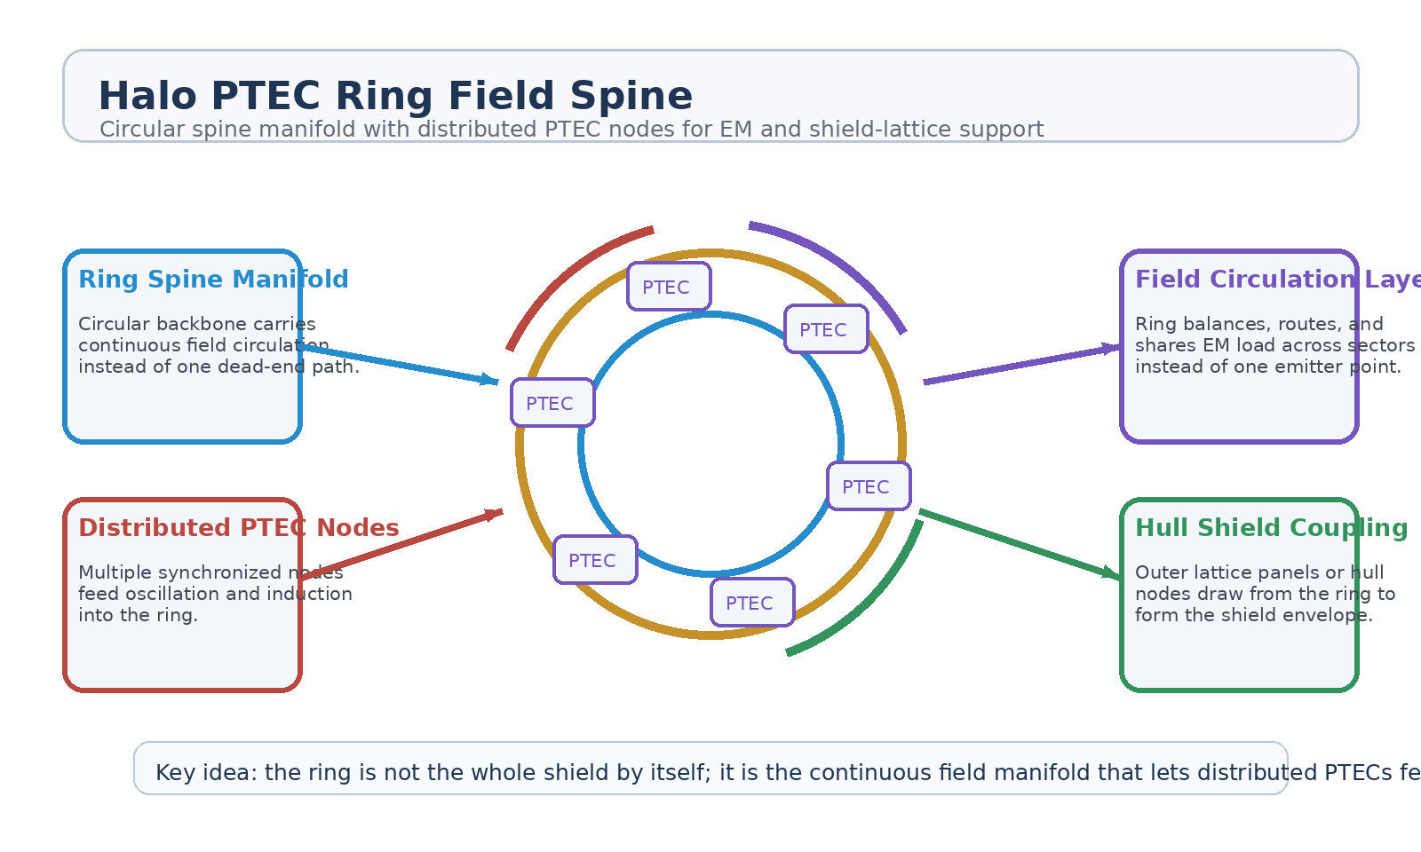
Figure 1. Halo PTEC Ring Field Spine with circular manifold, distributed PTEC nodes, field circulation, and hull-coupled shield support.
1. Concept Thesis
The core idea is that a shield-support system becomes more resilient when its routing geometry is circular rather than linear. A ring has no hard dead-end. Field energy can circulate continuously, sector load can be balanced around the loop, and reinforcement can be localized without depending on one source point. Distributed PTEC nodes then act as synchronized feed points that keep the ring energized and shaped.
This makes the ring behave less like a single emitter and more like a managed field bus or manifold feeding a larger hull-defense lattice.
2. Why the Ring Matters
• Enables continuous circulation instead of a point-source dead end.
• Improves balancing and redistribution of field load around the hull.
• Supports segmentation into multiple synchronized node sectors.
• Allows localized reinforcement on one arc without collapsing the full loop.
• Creates a cleaner coupling layer for shield panels, hull nodes, or prismatic shells.
3. System Architecture
Layer | Subsystem | Primary Function | Role
L1 | Ring Spine | Provides the circular structural and routing backbone. | Field manifold
L2 | Distributed PTEC Nodes | Inject oscillation, induction, and synchronized energy into the ring. | Feed points
L3 | Field Circulation Layer | Balances, routes, and shares EM load across the loop. | Continuous channel
L4 | Shield Coupling Layer | Transfers ring output into hull nodes, lattice panels, or shell sectors. | Envelope formation
L5 | Protected Volume | Receives the resulting EM field or shield-support effect. | Defensive outcome

3.1 Distributed PTEC Nodes
The PTEC nodes should be treated as synchronized ring feed points, not as isolated reactors. Each node contributes oscillation and induction into the manifold, while the ring itself distributes the resulting field behavior. This lets the architecture scale by adding more nodes, balancing sectors, or varying output density around the loop.
3.2 Continuous Field Circulation
The ring's biggest advantage is continuity. Instead of letting energy collect and terminate at one location, the field can circulate around the loop, reducing hot spots and making it easier to shift emphasis toward threatened sectors or damaged areas. In this sense the ring behaves like a field manifold rather than a one-shot projector.
3.3 Hull-Coupled Shield Generation
The ring should not be described as the shield by itself. It is the support architecture that feeds shield panels, hull nodes, or lattice surfaces. Those outer layers form the actual envelope. The ring provides the routing, balancing, and sector reinforcement underneath.
4. Defensive Roles
• Electromagnetic field generation across a distributed hull structure.
• Shield-lattice support rather than single-point shield emission.
• Localized arc or sector reinforcement during transient stress.
• Load sharing and redistribution around the vessel perimeter.
• Support for prismatic shell, lattice, or hull-node defensive layers.
5. Why This Is Stronger Than a Single Source
A single-source field architecture is easy to overload or localize. A ring architecture is harder to starve because the path is continuous and the feeds are distributed. That does not make it invulnerable. It simply gives the system a more honest and resilient way to generate, circulate, and couple field energy into the larger defense structure.
6. Boundaries and Realism
Halo PTEC Ring Field Spine is strongest as a support architecture for field generation and shield coupling. It should not be oversold as universal protection against every threat class or as a replacement for structural defense, segmentation, or passive shielding. Its value lies in circulation, balancing, and reinforcement where field behavior matters most.
• Best framed for EM generation, field shaping, and shield-support roles.
• Most coherent when paired with outer hull lattice or segmented shield panels.
• Less credible as a complete stand-alone answer to all radiation and kinetic threats.
• Should be described as the manifold behind the shield, not the entire shield by itself.
7. Proof-of-Concept Build Path
Phase | Goal | Bench / Program Activity | Success Signal
P1 | Ring manifold demo | Build a circular routing structure with multiple synthetic node inputs. | Continuous field-path baseline
P2 | Node synchronization | Coordinate multiple PTEC-like feed points around the ring. | Stable distributed feed behavior
P3 | Sector reinforcement | Bias output to one ring sector while preserving whole-loop continuity. | Localized reinforcement without collapse
P4 | Hull coupling model | Connect ring output into a segmented shell or lattice panel array. | Improved distributed envelope support
P5 | Stress review | Compare single-source and ring-manifold behavior under asymmetric load. | Clear balancing advantage

8. Conclusion
Halo PTEC Ring Field Spine turns the spine into a circular field manifold and the PTEC into a distributed node architecture. That combination is stronger than a single-source picture because it gives the system a continuous path for circulation, a better way to balance load, and a cleaner way to feed a larger shield lattice.
As a white paper PoC, the concept is best understood as the ring behind the shield: the infrastructure that lets distributed nodes keep an electromagnetic or shield-support envelope coherent across the hull.
Working one-line doctrine: The ring is not the whole shield; it is the continuous field manifold that lets distributed PTECs feed, balance, and reinforce the larger defensive lattice.

